The Child Friendly Logo.
**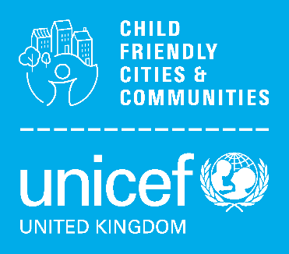Reflective Practice: Story of Change**

**Impact Study Development Template**

***Prompt Questions*:***

1. *What happened?*
2. *Who did it involve?*
3. *For how long did it run/is it ongoing?*
4. *What changed in terms of relationships and ways of working?*
5. *What changed in terms of child & youth engagement / experiences of how place/service feels?*
6. *What changed in how adult stakeholders spoke and acted in terms of a child rights-based approach?*
7. *What was the impact of the work for children & young people?*
8. *How do you know it was successful?*
9. *Is it sustainable/how will you keep it moving forwards?*
10. *What did you learn?*
11. *What did you learn about the conditions needed for this kind of change?*
12. *What would you do differently next time?*

*\*please use these as a guide, not all have to be answered*

**Proposed Impact Study:**

|  |  |
| --- | --- |
| **Nottingham’s CFC Badge(s)**  **Equal and Included**  **Education and**  **Learning**  **Safe and Secure**  **Healthy**   * Safe and Secure * Healthy * Education and Learning * Equal and Included (Golden Thread) * Culture * Co-operation and Leadership * Communication |  |
| **Outcome**  **(from Nottingham’s Action Plan)** |  |
| **How are the voices and experiences of seldom-heard (under representative) children and young people shaping this impact study?** |  |
| *Consider the 7 principles of a Child Rights-Based Approach (details below). Reflect on each one individually in relation to your chosen impact study. How does the example you’ve chosen demonstrate the principles in practice?* | |
| **Dignity** |  |
| **Participation** |  |
| **Life, Survival & Development** |  |
| **Non-discrimination** |  |
| **Transparency & Accountability** |  |
| **Best Interests** |  |
| **Interdependence & Indivisibility** |  |

Please email completed evidence form to [child.friendly@nottinghamcity.gov.uk](mailto:child.friendly@nottinghamcity.gov.uk)

